Senior Project Support Vector Machine

# Initial Model

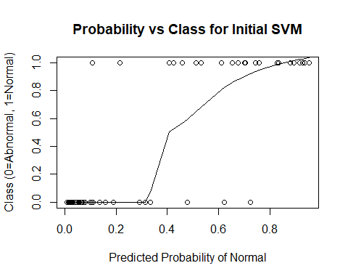

## Confusion Matrix and Statistics  
##   
## Reference  
## Prediction Abnormal Normal  
## Abnormal 38 5  
## Normal 2 17  
##   
## Accuracy : 0.8871   
## 95% CI : (0.7811, 0.9534)  
## No Information Rate : 0.6452   
## P-Value [Acc > NIR] : 1.515e-05   
##   
## Kappa : 0.7456   
## Mcnemar's Test P-Value : 0.4497   
##   
## Sensitivity : 0.9500   
## Specificity : 0.7727   
## Pos Pred Value : 0.8837   
## Neg Pred Value : 0.8947   
## Prevalence : 0.6452   
## Detection Rate : 0.6129   
## Detection Prevalence : 0.6935   
## Balanced Accuracy : 0.8614   
##   
## 'Positive' Class : Abnormal   
##

##   
## Parameter tuning of 'svm':  
##   
## - sampling method: 10-fold cross validation   
##   
## - best parameters:  
## gamma cost  
## 0.1 1  
##   
## - best performance: 0.1323333   
##   
## - Detailed performance results:  
## gamma cost error dispersion  
## 1 1e-05 1e-03 0.3148333 0.06779804  
## 2 1e-04 1e-03 0.3148333 0.06779804  
## 3 1e-03 1e-03 0.3148333 0.06779804  
## 4 1e-02 1e-03 0.3148333 0.06779804  
## 5 1e-01 1e-03 0.3148333 0.06779804  
## 6 1e-05 1e-02 0.3148333 0.06779804  
## 7 1e-04 1e-02 0.3148333 0.06779804  
## 8 1e-03 1e-02 0.3148333 0.06779804  
## 9 1e-02 1e-02 0.3148333 0.06779804  
## 10 1e-01 1e-02 0.3148333 0.06779804  
## 11 1e-05 1e-01 0.3148333 0.06779804  
## 12 1e-04 1e-01 0.3148333 0.06779804  
## 13 1e-03 1e-01 0.3148333 0.06779804  
## 14 1e-02 1e-01 0.3148333 0.06779804  
## 15 1e-01 1e-01 0.2708333 0.07764771  
## 16 1e-05 1e+00 0.3148333 0.06779804  
## 17 1e-04 1e+00 0.3148333 0.06779804  
## 18 1e-03 1e+00 0.3148333 0.06779804  
## 19 1e-02 1e+00 0.2266667 0.13152712  
## 20 1e-01 1e+00 0.1323333 0.05612596  
## 21 1e-05 1e+01 0.3148333 0.06779804  
## 22 1e-04 1e+01 0.3148333 0.06779804  
## 23 1e-03 1e+01 0.2265000 0.12364438  
## 24 1e-02 1e+01 0.1405000 0.06538608  
## 25 1e-01 1e+01 0.1363333 0.06254282

## Confusion Matrix and Statistics  
##   
## Reference  
## Prediction Abnormal Normal  
## Abnormal 38 4  
## Normal 2 18  
##   
## Accuracy : 0.9032   
## 95% CI : (0.8012, 0.9637)  
## No Information Rate : 0.6452   
## P-Value [Acc > NIR] : 3.301e-06   
##   
## Kappa : 0.7842   
## Mcnemar's Test P-Value : 0.6831   
##   
## Sensitivity : 0.9500   
## Specificity : 0.8182   
## Pos Pred Value : 0.9048   
## Neg Pred Value : 0.9000   
## Prevalence : 0.6452   
## Detection Rate : 0.6129   
## Detection Prevalence : 0.6774   
## Balanced Accuracy : 0.8841   
##   
## 'Positive' Class : Abnormal   
##

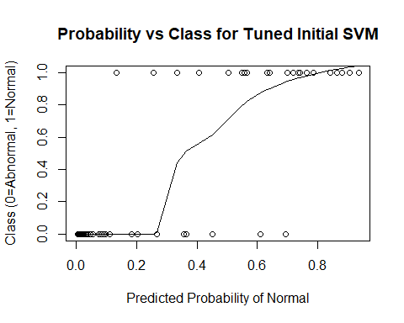

# Initial Model with Cross-Validation

## The following objects are masked from data:  
##   
## cervical_tilt, class, classification,  
## degree_spondylolisthesis, Direct_tilt, lumbar_lordosis_angle,  
## pelvic_incidence, pelvic_radius, pelvic_slope, pelvic_tilt,  
## sacral_slope, sacrum_angle, scoliosis_slope, thoracic_slope

## gamma cost  
## 25 0.1 10

## Confusion Matrix and Statistics  
##   
## Reference  
## Prediction Abnormal Normal  
## Abnormal 186 23  
## Normal 24 77  
##   
## Accuracy : 0.8484   
## 95% CI : (0.8035, 0.8864)  
## No Information Rate : 0.6774   
## P-Value [Acc > NIR] : 5.083e-12   
##   
## Kappa : 0.654   
## Mcnemar's Test P-Value : 1   
##   
## Sensitivity : 0.8857   
## Specificity : 0.7700   
## Pos Pred Value : 0.8900   
## Neg Pred Value : 0.7624   
## Prevalence : 0.6774   
## Detection Rate : 0.6000   
## Detection Prevalence : 0.6742   
## Balanced Accuracy : 0.8279   
##   
## 'Positive' Class : Abnormal   
##

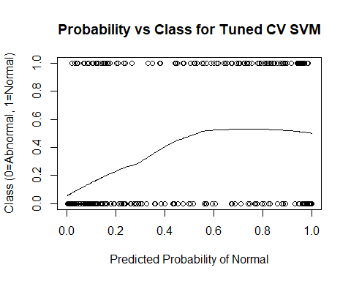

# Add Provided Random Noise

## gamma cost  
## 24 0.01 10

## Confusion Matrix and Statistics  
##   
## Reference  
## Prediction Abnormal Normal  
## Abnormal 184 27  
## Normal 26 73  
##   
## Accuracy : 0.829   
## 95% CI : (0.7824, 0.8692)  
## No Information Rate : 0.6774   
## P-Value [Acc > NIR] : 1.229e-09   
##   
## Kappa : 0.6078   
## Mcnemar's Test P-Value : 1   
##   
## Sensitivity : 0.8762   
## Specificity : 0.7300   
## Pos Pred Value : 0.8720   
## Neg Pred Value : 0.7374   
## Prevalence : 0.6774   
## Detection Rate : 0.5935   
## Detection Prevalence : 0.6806   
## Balanced Accuracy : 0.8031   
##   
## 'Positive' Class : Abnormal   
##

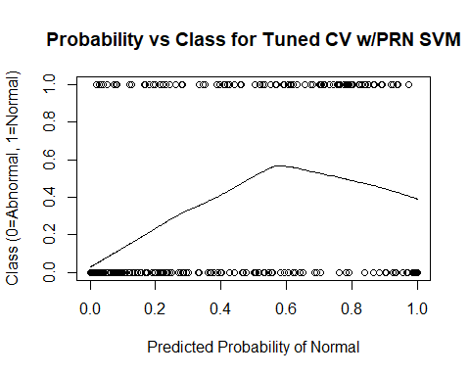

# Add 10 Random Variables

## gamma cost  
## 24 0.01 10

## Confusion Matrix and Statistics  
##   
## Reference  
## Prediction Abnormal Normal  
## Abnormal 181 29  
## Normal 29 71  
##   
## Accuracy : 0.8129   
## 95% CI : (0.765, 0.8548)  
## No Information Rate : 0.6774   
## P-Value [Acc > NIR] : 6.441e-08   
##   
## Kappa : 0.5719   
## Mcnemar's Test P-Value : 1   
##   
## Sensitivity : 0.8619   
## Specificity : 0.7100   
## Pos Pred Value : 0.8619   
## Neg Pred Value : 0.7100   
## Prevalence : 0.6774   
## Detection Rate : 0.5839   
## Detection Prevalence : 0.6774   
## Balanced Accuracy : 0.7860   
##   
## 'Positive' Class : Abnormal   
##

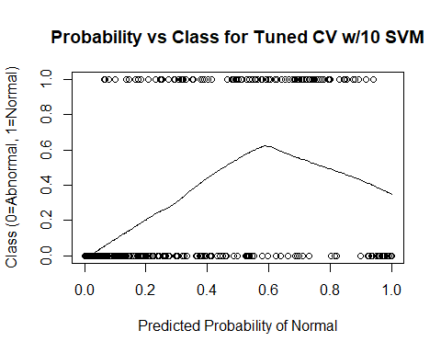

# Add 100 Random Variables

## gamma cost  
## 23 0.001 10

## Confusion Matrix and Statistics  
##   
## Reference  
## Prediction Abnormal Normal  
## Abnormal 169 55  
## Normal 41 45  
##   
## Accuracy : 0.6903   
## 95% CI : (0.6356, 0.7414)  
## No Information Rate : 0.6774   
## P-Value [Acc > NIR] : 0.3375   
##   
## Kappa : 0.2645   
## Mcnemar's Test P-Value : 0.1846   
##   
## Sensitivity : 0.8048   
## Specificity : 0.4500   
## Pos Pred Value : 0.7545   
## Neg Pred Value : 0.5233   
## Prevalence : 0.6774   
## Detection Rate : 0.5452   
## Detection Prevalence : 0.7226   
## Balanced Accuracy : 0.6274   
##   
## 'Positive' Class : Abnormal   
##

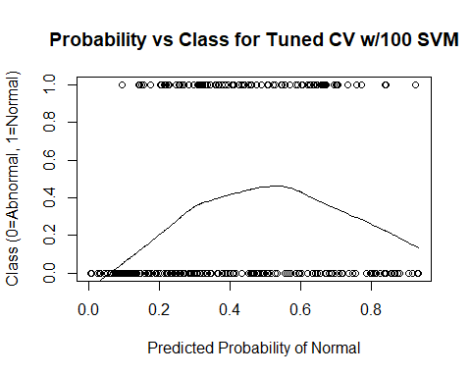

# Add 500 Random Variables

## gamma cost  
## 1 1e-05 0.001

## Confusion Matrix and Statistics  
##   
## Reference  
## Prediction Abnormal Normal  
## Abnormal 210 100  
## Normal 0 0  
##   
## Accuracy : 0.6774   
## 95% CI : (0.6223, 0.7292)  
## No Information Rate : 0.6774   
## P-Value [Acc > NIR] : 0.5271   
##   
## Kappa : 0   
## Mcnemar's Test P-Value : <2e-16   
##   
## Sensitivity : 1.0000   
## Specificity : 0.0000   
## Pos Pred Value : 0.6774   
## Neg Pred Value : NaN   
## Prevalence : 0.6774   
## Detection Rate : 0.6774   
## Detection Prevalence : 1.0000   
## Balanced Accuracy : 0.5000   
##   
## 'Positive' Class : Abnormal   
##

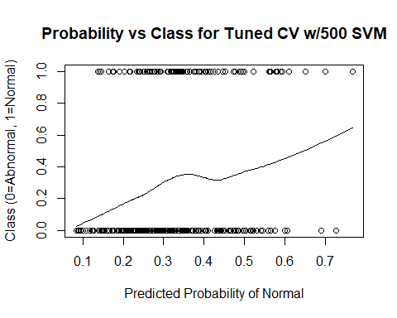

# Add 1000 Random Variables

## gamma cost  
## 23 0.001 10

## Confusion Matrix and Statistics  
##   
## Reference  
## Prediction Abnormal Normal  
## Abnormal 209 95  
## Normal 1 5  
##   
## Accuracy : 0.6903   
## 95% CI : (0.6356, 0.7414)  
## No Information Rate : 0.6774   
## P-Value [Acc > NIR] : 0.3375   
##   
## Kappa : 0.06   
## Mcnemar's Test P-Value : <2e-16   
##   
## Sensitivity : 0.9952   
## Specificity : 0.0500   
## Pos Pred Value : 0.6875   
## Neg Pred Value : 0.8333   
## Prevalence : 0.6774   
## Detection Rate : 0.6742   
## Detection Prevalence : 0.9806   
## Balanced Accuracy : 0.5226   
##   
## 'Positive' Class : Abnormal   
##

